razorpayClone — Functional Specification & Technical Design Document

Document Owner: Principal Fintech Architecture
System: razorpayClone — Payment Gateway Backend (Modular Monolith)
Stack: Java 25 / Spring Boot 4 (Spring Security, Spring Data JPA/Hibernate, Spring Kafka, Spring Data Redis) / PostgreSQL / Redis / Apache Kafka
Scope: This document is derived directly from the current codebase (com.preesa.razorpay) — entity fields, enum values, endpoints, and operational parameters reflect the real implementation, not idealized assumptions.

Table of Contents

1. Section 1 — Functional Specification Document (FSD)
2. Section 2 — Critical Architecture & Flow Diagrams
3. Section 3 — Technical Design Document (TDD)

SECTION 1: Functional Specification Document (FSD)

1.1 System Actors

Actor | Description | Interaction Surface
Merchant (Business) | Registered entity accepting payments. Owns API credentials, webhook config, settlement bank account. | /v1/auth/**, /v1/api/merchants/** (JWT-secured)
Merchant Team User | Human users of a merchant account with roles OWNER, ADMIN, TEAM (UserRole enum). Authenticates via email/password → JWT. | /v1/auth/login, /v1/auth/signup
End Customer | The payer. Identified optionally via Customer entity (name, email, contact) linked to a merchant. Not a direct API actor — initiates payment data (card/UPI/netbanking) through the merchant's checkout, which relays to the gateway. | Indirect — via PaymentInitRequest.methodDetails
Server-to-Server Integration (API Key Caller) | The merchant's backend server, authenticated via Key ID + Key Secret (HTTP Basic). Used for all transactional order/payment/refund/vault calls. | /v1/orders/**, /v1/payments/**, /v1/vault/**
Acquiring Partner / Bank Switch (Simulated) | Simulated bank/processor that asynchronously authorizes or declines payments. Implemented as a scheduled background poller (BankCallbackSimulator) rather than a live external bank in this environment. | Internal scheduled job, mutates Payment status
Admin / Ops Portal | Operational surface reserved under /v1/admin/** (JWT-protected route group) for internal staff — settlement oversight, DLQ review, merchant status management. | /v1/admin/**
Webhook Receiver (Merchant Endpoint) | The merchant's own HTTPS endpoint that receives signed event callbacks (payment.authorized, payment.captured, etc.). | Outbound HTTP POST from WebhookDeliverExecutor

1.2 Core Functional Modules

1.2.1 Merchant Management

- Registration (POST /v1/auth/signup): Creates a Merchant (business profile: name, email, business name, business type) and an owning AppUser (role OWNER). Merchant starts in MerchantStatus.PENDING_KYC.
- Business Profile & KYC: Merchant entity carries gstId, panId, businessType (LLP, PROPRIETORSHIP, PARTNERSHIP, PRIVATE_LIMITED, PUBLIC_LIMITED, TRUST), and settlement bank details (settlementBankAccount, settlementBankIFSC, settlementBankAccountHolderName). KYC verification transitions MerchantStatus: PENDING_KYC → ACTIVE (verified) or → SUSPENDED (risk/compliance action).
- Login (POST /v1/auth/login): Validates email/password (BCrypt) against AppUser, issues a JWT (LoginResponse.accessToken) containing sub=email, merchant_id, role, 24-hour expiry.
- API Credentials (/v1/api/merchants/api-keys):
  - Create (POST /create): Generates keyId (public) + keySecret (shown once, BCrypt-hashed as keySecretHash before storage) scoped to an Environment (DEV, UAT, PRODUCTION).
  - List (GET /getAllApiKey): Returns non-secret metadata only.
  - Revoke (DELETE /revoke/{keyId}): Disables the key (enabled=false).
  - Rotate (POST /rotate/{keyId}): Issues a new secret while preserving the old hash in previousKeySecretHash for a grace period (gracePeriodExpiresAt), allowing zero-downtime credential rotation.
- Webhook Configuration (/v1/api/merchants/webhooks): CRUD for MerchantWebhookConfig — target URL, per-merchant webhookSecret (HMAC signing key), and eventTypes subscription filter (comma-separated, or ALL).

1.2.2 Order Management

- POST /v1/orders/create creates an immutable OrderRecord:
  - amount (Money value object: amountUnits as Long in the lowest currency unit e.g. paise, + currency code).
  - receipt (merchant-supplied reconciliation ID, max 200 chars).
  - notes (arbitrary JSONB metadata map).
  - expireAt (TTL — orders not paid by this instant are eligible for expiry).
  - Optional inline customer (name/email/phone) — resolves/creates a Customer row.
  - Starts in OrderStatus.CREATED.
- Orders are never mutated on amount/currency/receipt after creation — only orderStatus and attempts (number of payment attempts linked to the order) change over the order's lifecycle.
- GET /v1/orders/get/{orderId} — fetch order.
- POST /v1/orders/cancel/{orderId} — explicit cancellation → OrderStatus.CANCELLED (only valid pre-payment).
- GET /v1/orders/getpayments/{orderId} — list all payment attempts against an order (supports retried/multiple-attempt flows).

1.2.3 Payment Processing Engine

- Multi-instrument support via PaymentMethod enum: CARD, NETBANKING, UPI, WALLET, routed by PaymentGatewayRouter to method-specific adapters (CardPaymentAdapter, NetBankingPaymentAdapter, UpiPaymentAdapter).
- Two-step flow — Authorization vs. Capture:
1. POST /v1/payments/initiate creates a Payment row (status CREATED → AUTHORIZING) and dispatches to the simulated bank switch asynchronously.
2. The BankCallbackSimulator (scheduled poller, default every 5s) resolves the authorization outcome based on configured per-method delay windows and success rates — moving the payment to AUTHORIZED or FAILED.
3. POST /v1/payments/{paymentId}/capture transitions AUTHORIZED → CAPTURING → CAPTURED (funds are only settled to the merchant once captured).
- Status model (PaymentStatus): CREATED, AUTHORIZING, AUTHORIZED, CAPTURING, CAPTURED, FAILED, CANCELLED, REFUNDED, PARTIALLY_REFUNDED, SETTLED, AUTH_EXPIRED — a strict superset of the simplified CREATED → PENDING → AUTHORIZED → CAPTURED/FAILED model, adding explicit CAPTURING (in-flight capture), AUTH_EXPIRED (authorized but not captured within window), settlement and refund terminal/semi-terminal states.
- Every transition is durably logged in PaymentTransitionLog (fromStatus, toStatus, actor — MERCHANT/CUSTOMER/SYSTEM, event — a PaymentEvent enum value, occurredAt) — giving a full forensic/audit trail per payment.
- Card payments never carry a raw PAN — the merchant passes a vault token (methodDetails: {"token": "<vault-token>"}) obtained from POST /v1/vault/tokenizer.

1.2.4 Webhook & Notification Engine

- Event-driven, Kafka-sourced, at-least-once delivery.
- Canonical event types produced from domain state changes and published via the Outbox pattern: payment.authorized, payment.captured, payment.failed, refund.processed (and order/settlement equivalents).
- WebhookKafkaConsumer consumes payments.events, orders.events, refunds.events, settlements.events, resolves each merchant's active subscribed MerchantWebhookConfig(s) for the event type, and creates a WebhookEvent row (status PENDING) per (merchant, config, event).
- Delivery is signed with HMAC-SHA256 using the merchant's webhookSecret, sent in the X-Razorpay-Signature header.
- Retry policy: exponential backoff schedule [1m, 5m, 30m, 2h, 8h, 24h] across up to 7 attempts; after exhaustion the event is moved to the Dead Letter Queue (DlqEvent, WebhookEventStatus.DEAD).
- A reconciliation sweep (every 10s) re-enqueues any PENDING webhook whose nextRetryAt has silently lapsed (crash-recovery safety net), using an idempotent "enqueue-if-absent" ZSet operation.

1.2.5 Refunds & Settlements

- Refunds: Triggered against a CAPTURED (or SETTLED) Payment. A Refund row (status PENDING → PROCESSING → PROCESSED/FAILED) is validated against the payment's remaining capturable balance — supports both partial (amount < captured amount, payment → PARTIALLY_REFUNDED) and full (amount == remaining balance, payment → REFUNDED) refunds. Multiple partial refunds are permitted until the captured amount is exhausted.
- Settlements: SettlementEngine runs daily (cron 0 0 23 * * *, 23:00 UTC) per merchant, aggregating all unsettled CAPTURED payments into a Settlement:
  - grossAmount = sum of captured amounts.
  - feeAmount = grossAmount × 2% (platform fee).
  - gstAmount = feeAmount × 18% (tax on fee, India GST).
  - netAmount = grossAmount − feeAmount − gstAmount → transferred to the merchant's settlement bank account.
  - Cross-referenced to constituent payments via SettlementPayment (composite key: settlementId + paymentId).
  - Status lifecycle: INITIATED → TRANSFER_PENDING → PROCESSED / FAILED.

1.3 State Transition Matrices

1.3.1 Order State Lifecycle

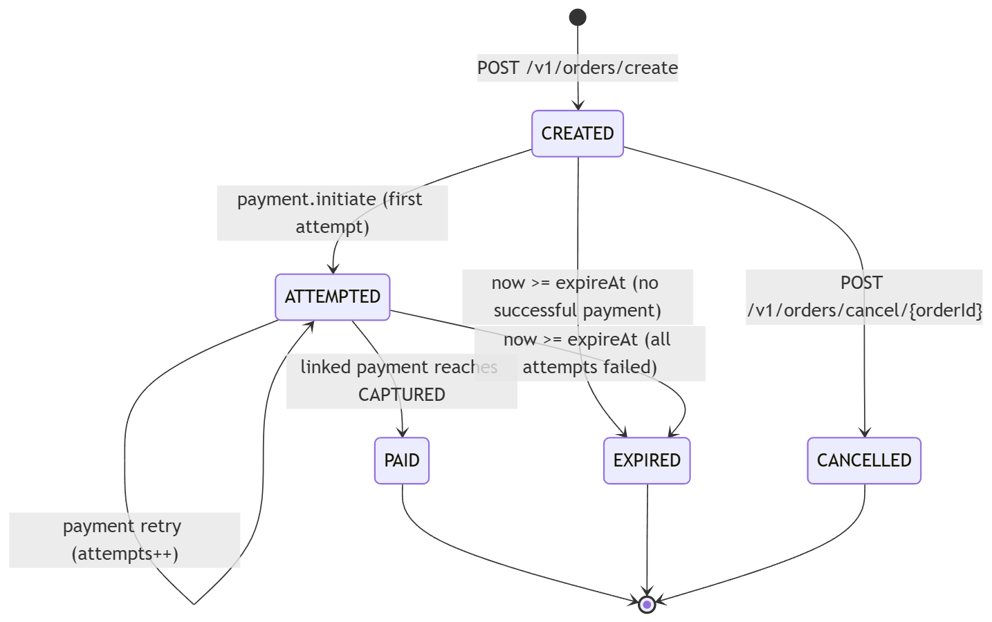

Note: the implemented OrderStatus enum is CREATED, ATTEMPTED, PAID, CANCELLED. EXPIRED is specified here as the functional requirement for TTL enforcement; see §4 Edge Cases for the recommended implementation note — it is currently handled operationally via expireAt comparison rather than a persisted terminal enum value, and should be promoted to an explicit status for correctness (see TDD §3.2 recommendation).

1.3.2 Payment State Lifecycle

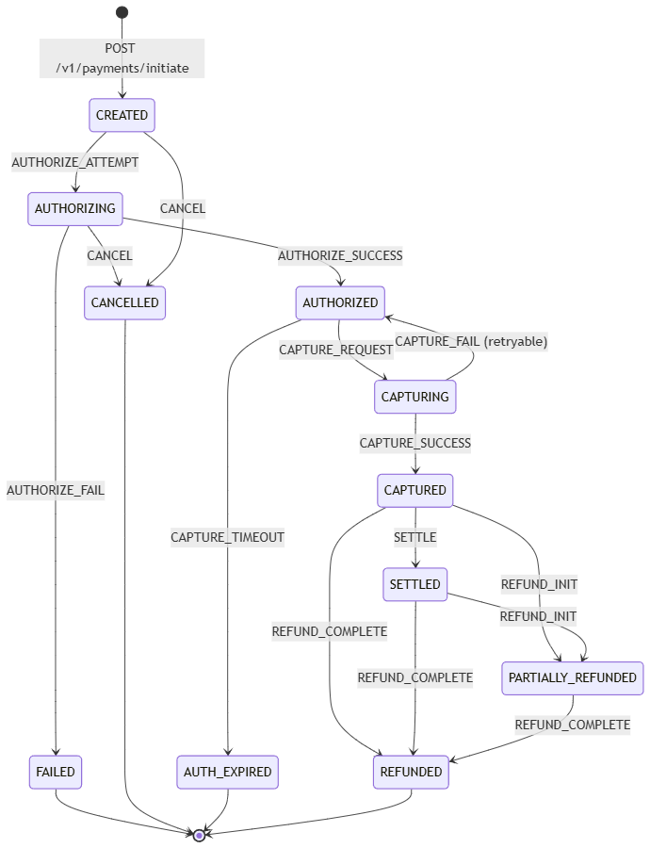

Each arrow above corresponds 1:1 to a PaymentEvent enum constant (AUTHORIZE_ATTEMPT, AUTHORIZE_SUCCESS, AUTHORIZE_FAIL, CAPTURE_REQUEST, CAPTURE_SUCCESS, CAPTURE_FAIL, REFUND_INIT, REFUND_COMPLETE, SETTLE, CANCEL, CAPTURE_TIMEOUT) and is persisted as a PaymentTransitionLog row.

1.4 Edge Cases & Resilience Rules

Scenario | Risk | Mitigation (as implemented / recommended)
Double-debit / duplicate charge | Customer double-clicks "Pay" or merchant retries a timed-out request, causing two Payment rows for one intent. | X-Idempotency-Key header enforced by IdempotencyFilter: a Redis key idempotency:{merchantId}:{rawKey} with an __IN_PROGRESS__ marker (30s TTL) blocks concurrent duplicate submissions; the completed response is cached for 24h and replayed verbatim on retry. Combined with a DB-level unique constraint recommendation on (order_id, idempotency_key) for payments as a second line of defense if Redis is unavailable (filter fails open on Redis errors — see below).
Idempotency store unavailable (Redis down) | Filter fails open (logs warning, allows request through) — duplicate risk increases while Redis is down. | Must be paired with a DB unique constraint on the idempotency key column so the second insert fails fast with a DuplicateResourceException (409) instead of creating a duplicate payment.
Late / out-of-order bank callback | BankCallbackSimulator resolves a payment after the merchant has already timed out and shown the customer a failure, or after the order's expireAt has passed. | State machine enforces valid-transition-only mutation (AUTHORIZING → AUTHORIZED/FAILED only); an authorization arriving after AUTH_EXPIRED triggers a compensating refund (auto-refund) rather than a silent capture, since the merchant has already been told the attempt failed.
Network timeout on client-gateway call | Client never receives the response although the order/payment was created server-side. | Client should retry with the same X-Idempotency-Key; server returns the cached prior result rather than creating a new resource. All initiate/capture/refund endpoints are designed to be safely retried under this contract.
Duplicate order IDs / receipts | Merchant submits the same receipt value twice, intending idempotent order creation. | receipt is not currently a uniqueness constraint (it is a free-text reconciliation field) — true idempotency must go through X-Idempotency-Key, not receipt. This is called out as a functional gap: recommend a unique index on (merchant_id, receipt) if receipt-based dedupe is a hard product requirement.
Capture after authorization window expires | Merchant calls /capture on a payment that sat AUTHORIZED too long. | CAPTURE_TIMEOUT event transitions to AUTH_EXPIRED (terminal, non-capturable); capture attempts against AUTH_EXPIRED are rejected with InvalidStateTransitionException (403).
Partial refund exceeding captured balance | Merchant issues refunds summing to more than the captured amount. | Refund service must validate sum(existing refunds) + requestedAmount <= payment.amount before creating a Refund row; violation raises BusinessRuleViolationException (409).
Webhook endpoint down / slow | Merchant's receiver is unreachable or returns 5xx. | Exponential backoff (1m → 24h) across 7 attempts, then DLQ; delivery never blocks the Kafka consumer thread (consumer ack happens on local persistence, not on HTTP delivery).
Rate limit / brute force on API keys | Repeated invalid Basic-auth attempts or scraping. | RateLimiter (token bucket or sliding window, Redis-backed) enforces per-key request/minute caps; exceeding returns 429 with X-RateLimit-Remaining / Retry-After headers (see prior fix: JWT auth failures now correctly return 401 via GlobalExceptionHandler's JwtException handler rather than 500).
Kafka outbox publish failure | Broker unreachable when OutboxPoller attempts to publish. | Up to 3 retry attempts tracked on OutBoxEvent.attempts; after exhaustion status = FAILED and is surfaced for manual/alerted reconciliation — the domain write already committed, so no business data is lost, only the async notification is delayed.

SECTION 2: Critical Architecture & Flow Diagrams

2.1 End-to-End Payment Flow

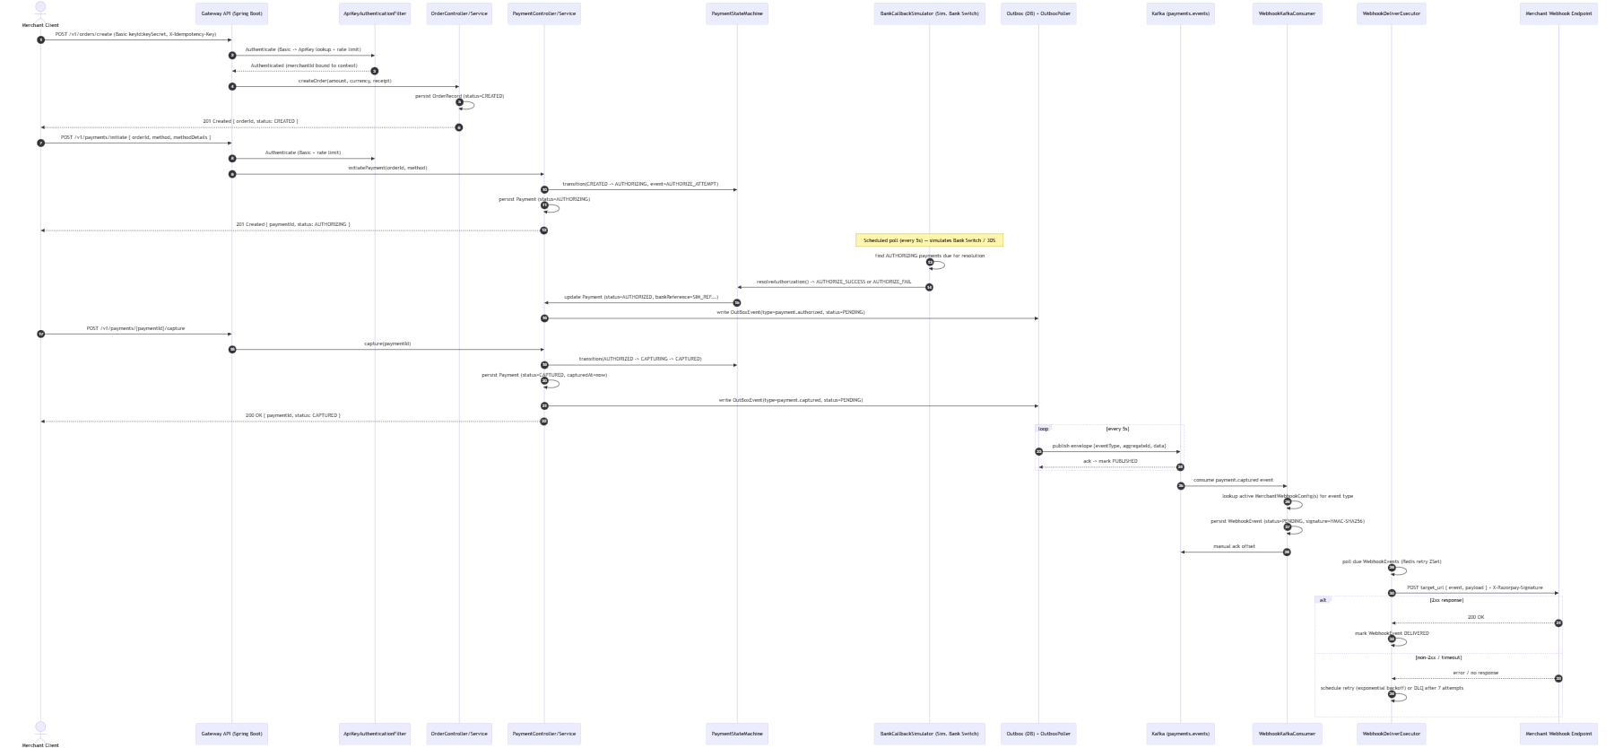

2.2 Distributed Idempotency & Concurrency Guard

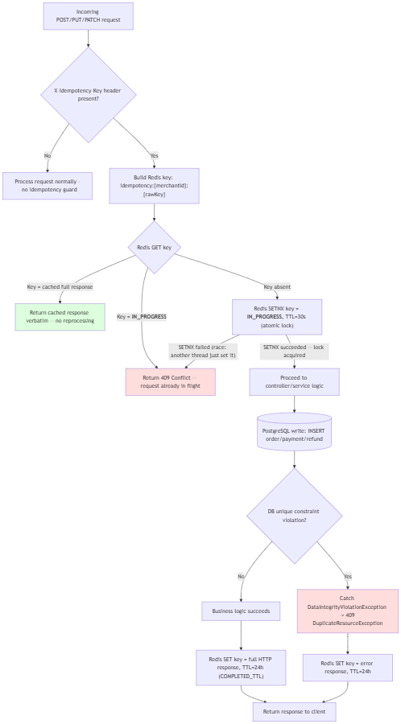

Defense in depth: the Redis SETNX lock prevents concurrent duplicate processing under normal operation; the PostgreSQL unique constraint on the idempotency key column is the backstop if Redis fails open (filter logs a warning and allows the request through rather than hard-failing the gateway on a cache outage).

2.3 Asynchronous Webhook Delivery Engine

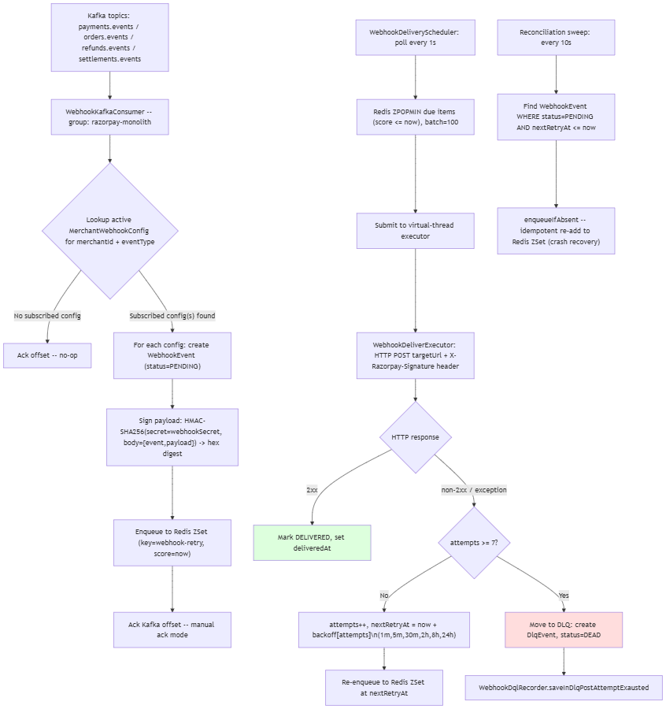

2.4 Partial & Full Refund Lifecycle

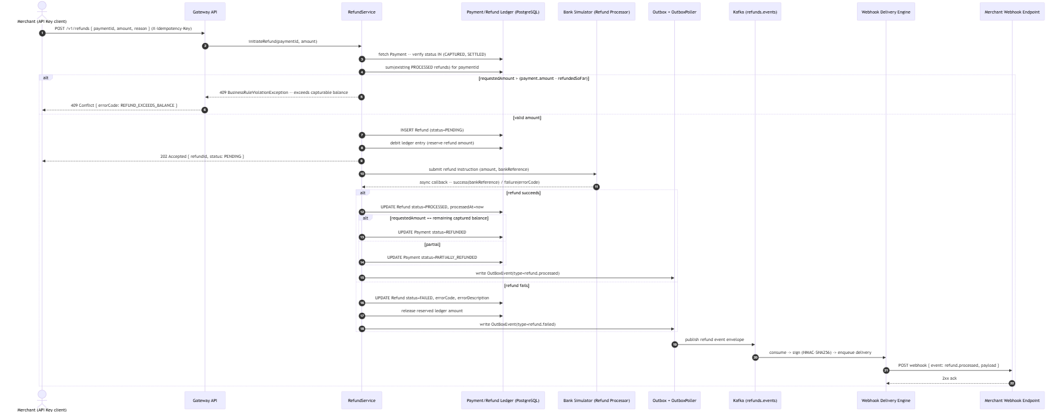

SECTION 3: Technical Design Document (TDD)

3.1 High-Level Component Architecture

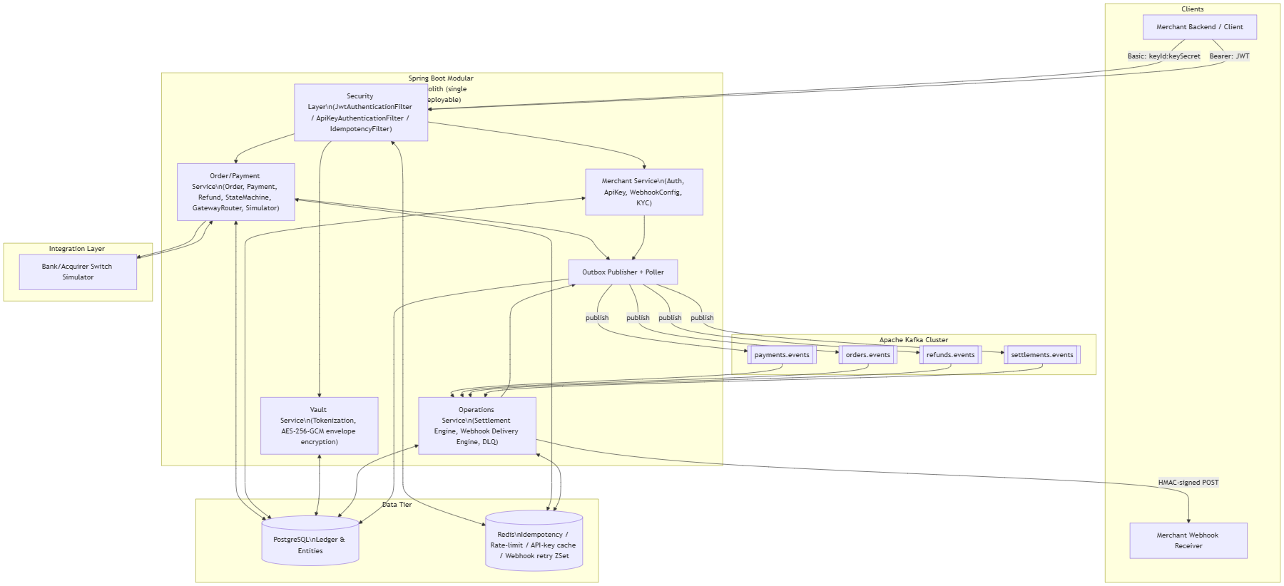

Component | Responsibility | Key Classes
API Gateway / Security Layer | AuthN/Z, idempotency, rate limiting at the servlet filter level, before requests reach controllers. | JwtAuthenticationFilter, ApiKeyAuthenticationFilter, IdempotencyFilter, WebSecurityConfig
Merchant Service | Merchant lifecycle, credential management, webhook subscription config. | AuthController, ApiKeyController, WebhookConfigController
Order/Payment Service | Order creation, payment state machine, method routing, simulated bank authorization. | OrderController, PaymentController, PaymentStateMachine, PaymentGatewayRouter, BankCallbackSimulator
Vault Service | PCI-scope isolation — tokenizes card PANs, never exposes raw card data to the rest of the system. | VaultController, VaultEncryptionConfig, VaultCard, CardToken
Webhook Worker (Operations) | Consumes domain events, signs and delivers webhooks, manages retries/DLQ. | WebhookKafkaConsumer, WebhookDeliverExecutor, WebhookRetryQueue, WebhookDeliveryScheduler, WebhookDqlRecorder
Settlement Engine (Operations) | Daily merchant payout computation and bank transfer initiation. | SettlementEngine, SettlementTransactionExecutor
Outbox Publisher/Poller | Transactional outbox pattern — guarantees at-least-once Kafka publication without dual-write inconsistency. | OutBoxEventPublisher, OutboxPoller, OutboxResultHandler
Kafka Cluster | Durable, ordered, partitioned event bus decoupling writers (payment/order/refund/settlement services) from the webhook worker. | Topics: payments.events, orders.events, refunds.events, settlements.events
Redis | Low-latency distributed state: idempotency locks, rate-limit counters, API key cache, webhook retry schedule (ZSet). | RedisIdempotencyStore, TokenBucketRateLimiter / SlidingWindowRateLimiter, ApiKeyCache, WebhookRetryQueue
PostgreSQL | System of record — merchants, orders, payments, refunds, settlements, webhook events, outbox, vault. | All @Entity classes

3.2 Database Schema & Data Models

Money is an @Embeddable value object reused across tables as {prefix}_amount_units BIGINT + {prefix}_currency VARCHAR(3).

-- =========================================================
-- MERCHANT DOMAIN
-- =========================================================
CREATE TYPE business_type AS ENUM (
'LLP', 'PROPRIETORSHIP', 'PARTNERSHIP', 'PRIVATE_LIMITED', 'PUBLIC_LIMITED', 'TRUST'
);
CREATE TYPE merchant_status AS ENUM ('PENDING_KYC', 'ACTIVE', 'SUSPENDED');
CREATE TABLE merchants (
id UUID PRIMARY KEY DEFAULT gen_random_uuid(),
name VARCHAR(200) NOT NULL,
email VARCHAR(255) NOT NULL,
contact_number VARCHAR(15),
website_url VARCHAR(200),
business_name VARCHAR(50),
business_type business_type,
status merchant_status NOT NULL DEFAULT 'PENDING_KYC',
gst_id VARCHAR(50),
pan_id VARCHAR(20),
settlement_bank_account VARCHAR(200),
settlement_bank_ifsc VARCHAR(20),
settlement_bank_account_holder_name VARCHAR(200),
created_by VARCHAR(255),
updated_by VARCHAR(255),
created_at TIMESTAMPTZ NOT NULL DEFAULT now(),
updated_at TIMESTAMPTZ NOT NULL DEFAULT now(),
CONSTRAINT uq_merchants_email UNIQUE (email)
);
CREATE INDEX idx_merchant_status ON merchants (status);
CREATE TYPE user_role AS ENUM ('OWNER', 'ADMIN', 'TEAM');
CREATE TABLE app_users (
id UUID PRIMARY KEY DEFAULT gen_random_uuid(),
merchant_id UUID NOT NULL REFERENCES merchants (id),
email VARCHAR(255) NOT NULL,
password_hash VARCHAR(255) NOT NULL,
role user_role NOT NULL,
created_at TIMESTAMPTZ NOT NULL DEFAULT now(),
updated_at TIMESTAMPTZ NOT NULL DEFAULT now(),
CONSTRAINT uq_app_users_email UNIQUE (email)
);
CREATE INDEX idx_app_user_merchant_id ON app_users (merchant_id);
CREATE TYPE environment AS ENUM ('DEV', 'UAT', 'PRODUCTION');
CREATE TABLE merchant_keys (
id UUID PRIMARY KEY DEFAULT gen_random_uuid(),
merchant_id UUID NOT NULL REFERENCES merchants (id),
key_id VARCHAR(50) NOT NULL,
hashed_key_secret VARCHAR(200) NOT NULL,
previous_key_secret_hash VARCHAR(200),
environment environment NOT NULL,
enabled BOOLEAN NOT NULL DEFAULT TRUE,
last_used_at TIMESTAMPTZ,
rotated_at TIMESTAMPTZ,
grace_period_expires_at TIMESTAMPTZ,
created_at TIMESTAMPTZ NOT NULL DEFAULT now(),
updated_at TIMESTAMPTZ NOT NULL DEFAULT now(),
CONSTRAINT uq_merchant_keys_key_id UNIQUE (key_id)
);
CREATE INDEX idx_api_key_merchant_id ON merchant_keys (merchant_id, enabled);
CREATE TABLE merchant_webhook_configs (
id UUID PRIMARY KEY DEFAULT gen_random_uuid(),
merchant_id UUID NOT NULL REFERENCES merchants (id),
target_url VARCHAR(500) NOT NULL,
webhook_secret VARCHAR(255) NOT NULL,
event_types VARCHAR(1000),
enabled BOOLEAN NOT NULL DEFAULT TRUE,
created_at TIMESTAMPTZ NOT NULL DEFAULT now(),
updated_at TIMESTAMPTZ NOT NULL DEFAULT now()
);
CREATE INDEX idx_merchant_webhook ON merchant_webhook_configs (merchant_id, enabled);
CREATE TABLE customers (
id UUID PRIMARY KEY DEFAULT gen_random_uuid(),
merchant_id UUID NOT NULL REFERENCES merchants (id),
name VARCHAR(200) NOT NULL,
email VARCHAR(50),
contact_number VARCHAR(15),
gst_id VARCHAR(50),
created_at TIMESTAMPTZ NOT NULL DEFAULT now(),
updated_at TIMESTAMPTZ NOT NULL DEFAULT now()
);
CREATE INDEX idx_customer_merchant_id ON customers (merchant_id);
-- =========================================================
-- ORDER / PAYMENT DOMAIN
-- =========================================================
CREATE TYPE order_status AS ENUM ('CREATED', 'ATTEMPTED', 'PAID', 'CANCELLED');
CREATE TABLE orders (
id UUID PRIMARY KEY DEFAULT gen_random_uuid(),
merchant_id UUID NOT NULL REFERENCES merchants (id),
customer_id UUID REFERENCES customers (id),
order_status order_status NOT NULL DEFAULT 'CREATED',
amount_units BIGINT NOT NULL,
currency VARCHAR(3) NOT NULL,
receipt VARCHAR(200),
attempts INTEGER NOT NULL DEFAULT 0,
notes JSONB,
expire_at TIMESTAMPTZ,
created_by VARCHAR(255),
updated_by VARCHAR(255),
created_at TIMESTAMPTZ NOT NULL DEFAULT now(),
updated_at TIMESTAMPTZ NOT NULL DEFAULT now()
);
CREATE INDEX idx_order_status ON orders (merchant_id, order_status);
CREATE INDEX idx_merchants_orders ON orders (id, merchant_id);
-- Recommended addition for receipt-based dedupe (see FSD 1.4):
CREATE UNIQUE INDEX uq_orders_merchant_receipt ON orders (merchant_id, receipt) WHERE receipt IS NOT NULL;
CREATE TYPE payment_status AS ENUM (
'CREATED', 'AUTHORIZING', 'AUTHORIZED', 'CAPTURING', 'CAPTURED',
'FAILED', 'CANCELLED', 'REFUNDED', 'PARTIALLY_REFUNDED', 'SETTLED', 'AUTH_EXPIRED'
);
CREATE TYPE payment_method AS ENUM ('CARD', 'NETBANKING', 'UPI', 'WALLET');
CREATE TABLE payments (
id UUID PRIMARY KEY DEFAULT gen_random_uuid(),
merchant_id UUID NOT NULL REFERENCES merchants (id),
order_id UUID NOT NULL REFERENCES orders (id),
status payment_status NOT NULL,
amount_units BIGINT NOT NULL,
currency VARCHAR(3) NOT NULL,
method payment_method,
method_details JSONB,
idempotency_key VARCHAR(100),
bank_reference VARCHAR(100),
processor_reference VARCHAR(100),
error_code VARCHAR(50),
error_description VARCHAR(255),
authorized_at TIMESTAMPTZ,
captured_at TIMESTAMPTZ,
failed_at TIMESTAMPTZ,
refunded_at TIMESTAMPTZ,
settled_at TIMESTAMPTZ,
created_by VARCHAR(255),
updated_by VARCHAR(255),
created_at TIMESTAMPTZ NOT NULL DEFAULT now(),
updated_at TIMESTAMPTZ NOT NULL DEFAULT now()
);
CREATE INDEX idx_merchant_payment_status ON payments (merchant_id, status);
CREATE INDEX idx_merchants_payment ON payments (id, merchant_id);
-- Recommended addition for idempotent payment creation (see FSD 1.4):
CREATE UNIQUE INDEX uq_payments_order_idempotency ON payments (order_id, idempotency_key) WHERE idempotency_key IS NOT NULL;
CREATE TYPE payment_actor AS ENUM ('MERCHANT', 'CUSTOMER', 'SYSTEM');
CREATE TYPE payment_event AS ENUM (
'AUTHORIZE_ATTEMPT', 'AUTHORIZE_SUCCESS', 'AUTHORIZE_FAIL', 'CAPTURE_REQUEST',
'CAPTURE_SUCCESS', 'CAPTURE_FAIL', 'REFUND_INIT', 'REFUND_COMPLETE', 'SETTLE',
'CANCEL', 'CAPTURE_TIMEOUT'
);
CREATE TABLE payment_transition_logs (
id UUID PRIMARY KEY DEFAULT gen_random_uuid(),
payment_id UUID NOT NULL REFERENCES payments (id),
from_status payment_status NOT NULL,
to_status payment_status NOT NULL,
actor payment_actor NOT NULL,
event payment_event NOT NULL,
occurred_at TIMESTAMPTZ NOT NULL DEFAULT now()
);
CREATE INDEX idx_log_payment_id ON payment_transition_logs (payment_id, event);
CREATE TYPE refund_status AS ENUM ('PENDING', 'PROCESSING', 'PROCESSED', 'FAILED');
CREATE TABLE refunds (
id UUID PRIMARY KEY DEFAULT gen_random_uuid(),
merchant_id UUID NOT NULL REFERENCES merchants (id),
payment_id UUID NOT NULL REFERENCES payments (id),
amount_units BIGINT NOT NULL,
currency VARCHAR(3) NOT NULL,
status refund_status NOT NULL DEFAULT 'PENDING',
reason VARCHAR(255),
bank_reference VARCHAR(100),
error_code VARCHAR(50),
error_description VARCHAR(255),
notes JSONB,
processed_at TIMESTAMPTZ,
created_at TIMESTAMPTZ NOT NULL DEFAULT now(),
updated_at TIMESTAMPTZ NOT NULL DEFAULT now()
);
CREATE INDEX idx_refund_payment_id_status ON refunds (payment_id, status);
CREATE INDEX idx_refund_merchant_id ON refunds (merchant_id);
-- =========================================================
-- OUTBOX / EVENTING
-- =========================================================
CREATE TYPE event_aggregate_type AS ENUM ('PAYMENT', 'ORDER', 'SETTLEMENT', 'REFUND');
CREATE TYPE outbox_status AS ENUM ('PENDING', 'PUBLISHED', 'FAILED');
CREATE TABLE outbox_events (
id UUID PRIMARY KEY DEFAULT gen_random_uuid(),
aggregate_type event_aggregate_type NOT NULL,
aggregate_id UUID NOT NULL,
event_type VARCHAR(50) NOT NULL,
payload JSONB NOT NULL,
status outbox_status NOT NULL DEFAULT 'PENDING',
attempts INTEGER NOT NULL DEFAULT 0,
last_error VARCHAR(1000),
published_at TIMESTAMPTZ,
created_at TIMESTAMPTZ NOT NULL DEFAULT now()
);
CREATE INDEX idx_outbox_status_created ON outbox_events (status, created_at);
-- =========================================================
-- OPERATIONS: WEBHOOKS, DLQ, SETTLEMENT
-- =========================================================
CREATE TYPE webhook_event_status AS ENUM ('PENDING', 'DELIVERED', 'FAILED', 'DEAD');
CREATE TABLE webhook_events (
id UUID PRIMARY KEY DEFAULT gen_random_uuid(),
merchant_id UUID NOT NULL REFERENCES merchants (id),
event_type VARCHAR(100) NOT NULL,
status webhook_event_status NOT NULL,
payload JSONB,
target_url VARCHAR(500) NOT NULL,
signature VARCHAR(255) NOT NULL,
attempts INTEGER NOT NULL DEFAULT 0,
last_retry_at TIMESTAMPTZ,
last_attempt_at TIMESTAMPTZ,
last_response_code INTEGER,
last_response_body VARCHAR(1000),
next_retry_at TIMESTAMPTZ,
delivered_at TIMESTAMPTZ,
created_at TIMESTAMPTZ NOT NULL DEFAULT now()
);
CREATE INDEX idx_webhook_merchant_status ON webhook_events (merchant_id, status);
CREATE INDEX idx_webhook_next_retry ON webhook_events (status, next_retry_at);
CREATE TABLE dlq_events (
id UUID PRIMARY KEY DEFAULT gen_random_uuid(),
merchant_id UUID NOT NULL REFERENCES merchants (id),
webhook_event_id UUID NOT NULL REFERENCES webhook_events (id),
payload JSONB,
final_error VARCHAR(2000),
moved_at TIMESTAMPTZ NOT NULL DEFAULT now(),
replayed_at TIMESTAMPTZ,
CONSTRAINT uq_dlq_webhook_event UNIQUE (webhook_event_id)
);
CREATE TYPE settlement_status AS ENUM ('INITIATED', 'TRANSFER_PENDING', 'PROCESSED', 'FAILED');
CREATE TABLE settlements (
id UUID PRIMARY KEY DEFAULT gen_random_uuid(),
merchant_id UUID NOT NULL REFERENCES merchants (id),
gross_amount_units BIGINT NOT NULL,
gross_currency VARCHAR(3) NOT NULL,
refund_amount_units BIGINT NOT NULL DEFAULT 0,
refund_currency VARCHAR(3) NOT NULL,
fee_amount_units BIGINT NOT NULL,
fee_currency VARCHAR(3) NOT NULL,
gst_amount_units BIGINT NOT NULL,
gst_currency VARCHAR(3) NOT NULL,
net_amount_units BIGINT NOT NULL,
net_currency VARCHAR(3) NOT NULL,
bank_reference VARCHAR(100),
status settlement_status NOT NULL DEFAULT 'INITIATED',
settled_at TIMESTAMPTZ,
failure_reason VARCHAR(500),
created_at TIMESTAMPTZ NOT NULL DEFAULT now()
);
CREATE INDEX idx_settlement_merchant_status ON settlements (merchant_id, status);
CREATE TABLE settlement_payments (
settlement_id UUID NOT NULL REFERENCES settlements (id),
payment_id UUID NOT NULL REFERENCES payments (id),
PRIMARY KEY (settlement_id, payment_id)
);
-- =========================================================
-- VAULT (TOKENIZATION)
-- =========================================================
CREATE TYPE card_brand AS ENUM ('VISA', 'RUPAY', 'MASTERCARD', 'AMEX');
CREATE TABLE vault_cards (
id UUID PRIMARY KEY DEFAULT gen_random_uuid(),
last_four VARCHAR(4) NOT NULL,
bin VARCHAR(6) NOT NULL,
brand card_brand NOT NULL,
encrypted_pan BYTEA NOT NULL,
encrypted_dek BYTEA NOT NULL,
card_holder_name VARCHAR(255) NOT NULL,
expiry_month VARCHAR(2) NOT NULL,
expiry_year VARCHAR(4) NOT NULL,
deleted_at TIMESTAMPTZ,
created_at TIMESTAMPTZ NOT NULL DEFAULT now()
);
CREATE TABLE card_tokens (
id UUID PRIMARY KEY DEFAULT gen_random_uuid(),
merchant_id UUID NOT NULL REFERENCES merchants (id),
customer_id UUID REFERENCES customers (id),
token VARCHAR(50) NOT NULL,
vault_card_id UUID NOT NULL REFERENCES vault_cards (id),
revoked_at TIMESTAMPTZ,
created_at TIMESTAMPTZ NOT NULL DEFAULT now(),
CONSTRAINT uq_card_tokens_token UNIQUE (token)
);

3.3 API Contracts

All responses use the shared envelope on error: ErrorResponse { errorCode, errorMessage, timestamp, fieldErrors[] }.

3.3.1 POST /api/v1/orders

Request Headers
Authorization: Basic base64(keyId:keySecret)
X-Idempotency-Key: 8f14e45f-ceea-467e-bd3b-7f8f8f1f1a11
Content-Type: application/json

Request Body
{
"amount": {
"amountUnits": 50000,
"currency": "INR"
},
"receipt": "receipt#rcpt_00123",
"notes": {
"orderSource": "mobile_app",
"campaign": "diwali_sale"
},
"expireAt": "2026-10-04T10:00:00Z",
"customer": {
"name": "Ravi Kumar",
"email": "ravi.kumar@example.com",
"phone": "+919876543210"
}
}

Success Response — 201 Created
{
"orderId": "b3f1c2a4-5e6d-4a7b-9c8d-1e2f3a4b5c6d",
"merchantId": "11111111-2222-3333-4444-555555555555",
"customerId": "22222222-3333-4444-5555-666666666666",
"amount": {
"amountUnits": 50000,
"currency": "INR"
},
"receipt": "receipt#rcpt_00123",
"notes": {
"orderSource": "mobile_app",
"campaign": "diwali_sale"
},
"orderStatus": "CREATED",
"attempts": 0,
"expireAt": "2026-10-04T10:00:00Z",
"createdAt": "2026-10-03T10:00:00Z"
}

Error Response — 400 Bad Request (validation failure)
{
"errorCode": "VAIDATION_FAILED",
"errorMessage": "Request Validation Failed",
"timestamp": "2026-10-03T10:00:00Z",
"fieldErrors": [
{ "field": "amount.amountUnits", "message": "must not be null" }
]
}

Error Response — 401 Unauthorized (missing/invalid API key)
{
"errorCode": "INVALID_API_KEY",
"errorMessage": "Invalid or missing API credentials",
"timestamp": "2026-10-03T10:00:00Z",
"fieldErrors": null
}

Error Response — 429 Too Many Requests
{
"errorCode": "RATE_LIMIT_EXCEPTION",
"errorMessage": "Too many request for keyId key_abc123",
"timestamp": "2026-10-03T10:00:00Z",
"fieldErrors": null
}
Headers: X-RateLimit-Remaining: 0, X-Retry-After: 45, X-RateLimit-Reset: 1759500000

3.3.2 POST /api/v1/payments/charge

Implemented in this codebase as POST /v1/payments/initiate (authorization step) followed by POST /v1/payments/{paymentId}/capture.

Request Headers
Authorization: Basic base64(keyId:keySecret)
X-Idempotency-Key: 4c9b6a2e-1d3f-4b5a-8e7c-6f5d4c3b2a19
Content-Type: application/json

Request Body
{
"orderId": "b3f1c2a4-5e6d-4a7b-9c8d-1e2f3a4b5c6d",
"paymentMethod": "CARD",
"methodDetails": {
"token": "tok_8f3a9c2b1d4e5f6a7b8c9d0e1f2a3b4c"
}
}

Success Response — 201 Created
{
"id": "9a8b7c6d-5e4f-3a2b-1c0d-9e8f7a6b5c4d",
"merchantId": "11111111-2222-3333-4444-555555555555",
"orderId": "b3f1c2a4-5e6d-4a7b-9c8d-1e2f3a4b5c6d",
"amount": {
"amountUnits": 50000,
"currency": "INR"
},
"paymentStatus": "AUTHORIZING",
"method": "CARD",
"methodDetails": {
"token": "tok_8f3a9c2b1d4e5f6a7b8c9d0e1f2a3b4c"
},
"bankReference": null,
"errorCode": null,
"errorDescription": null,
"settledAt": null,
"createdAt": "2026-10-03T10:05:00Z"
}

Capture Request — POST /v1/payments/{paymentId}/capture

Success Response — 200 OK
{
"id": "9a8b7c6d-5e4f-3a2b-1c0d-9e8f7a6b5c4d",
"merchantId": "11111111-2222-3333-4444-555555555555",
"orderId": "b3f1c2a4-5e6d-4a7b-9c8d-1e2f3a4b5c6d",
"amount": {
"amountUnits": 50000,
"currency": "INR"
},
"paymentStatus": "CAPTURED",
"method": "CARD",
"methodDetails": {
"token": "tok_8f3a9c2b1d4e5f6a7b8c9d0e1f2a3b4c"
},
"bankReference": "SIM_REF9F3A2C1B",
"errorCode": null,
"errorDescription": null,
"settledAt": null,
"createdAt": "2026-10-03T10:05:00Z"
}

Error Response — 403 Forbidden (invalid state transition — e.g. capture on AUTH_EXPIRED)
{
"errorCode": "STATUS_TRANSITION_NOT_ALLOWED",
"errorMessage": "Cannot capture payment in state AUTH_EXPIRED",
"timestamp": "2026-10-03T10:30:00Z",
"fieldErrors": null
}

3.3.3 POST /api/v1/refunds

Request Headers
Authorization: Basic base64(keyId:keySecret)
X-Idempotency-Key: 1a2b3c4d-5e6f-7a8b-9c0d-1e2f3a4b5c6d
Content-Type: application/json

Request Body
{
"paymentId": "9a8b7c6d-5e4f-3a2b-1c0d-9e8f7a6b5c4d",
"amount": {
"amountUnits": 20000,
"currency": "INR"
},
"reason": "Customer requested partial cancellation of order items"
}

Success Response — 202 Accepted
{
"refundId": "5f4e3d2c-1b0a-9f8e-7d6c-5b4a3c2d1e0f",
"paymentId": "9a8b7c6d-5e4f-3a2b-1c0d-9e8f7a6b5c4d",
"amount": {
"amountUnits": 20000,
"currency": "INR"
},
"status": "PENDING",
"reason": "Customer requested partial cancellation of order items",
"createdAt": "2026-10-03T11:00:00Z"
}

Error Response — 409 Conflict (exceeds capturable balance)
{
"errorCode": "REFUND_EXCEEDS_BALANCE",
"errorMessage": "Refund amount exceeds remaining capturable balance of 30000 INR",
"timestamp": "2026-10-03T11:00:00Z",
"fieldErrors": null
}

3.3.4 POST /api/v1/webhooks/retry

Request Headers
Authorization: Bearer <JWT accessToken>
Content-Type: application/json

Request Body
{
"webhookEventId": "aa11bb22-cc33-dd44-ee55-ff6677889900"
}

Success Response — 200 OK
{
"webhookEventId": "aa11bb22-cc33-dd44-ee55-ff6677889900",
"status": "PENDING",
"attempts": 3,
"nextRetryAt": "2026-10-03T11:05:00Z"
}

Incoming webhook delivery headers (outbound to merchant, for reference):
Content-Type: application/json
X-Razorpay-Signature: 3f2e1d0c9b8a7f6e5d4c3b2a1f0e9d8c7b6a5f4e3d2c1b0a9f8e7d6c5b4a3f2e

3.4 Security & Cryptography

3.4.1 HMAC-SHA256 Webhook Signature

Signed payload: the exact JSON envelope delivered to the merchant ({"event": "<eventType>", "payload": {...}}), signed with the per-merchant webhookSecret from MerchantWebhookConfig.

Mac mac = Mac.getInstance("HmacSHA256");
mac.init(new SecretKeySpec(webhookSecret.getBytes(StandardCharsets.UTF_8), "HmacSHA256"));
byte[] digest = mac.doFinal(requestBody.getBytes(StandardCharsets.UTF_8));
String signature = HexFormat.of().formatHex(digest);
// sent as: X-Razorpay-Signature: <signature>

For a non-webhook, request-level signature use case such as order_id + "|" + payment_id (e.g. client-side payment verification, analogous to Razorpay's razorpay_signature check):

String signedPayload = orderId + "|" + paymentId;
Mac mac = Mac.getInstance("HmacSHA256");
mac.init(new SecretKeySpec(secretKey.getBytes(StandardCharsets.UTF_8), "HmacSHA256"));
byte[] digest = mac.doFinal(signedPayload.getBytes(StandardCharsets.UTF_8));
String signature = HexFormat.of().formatHex(digest);

Merchant-side verification (recommended contract to document for integrators):
1. Recompute the HMAC over the raw received body using the shared secret.
2. Compare using a constant-time equality check (MessageDigest.isEqual), never String.equals, to avoid timing attacks.
3. Reject the request if signatures mismatch or the header is absent.

3.4.2 Token-Based API Authentication Filter Flow

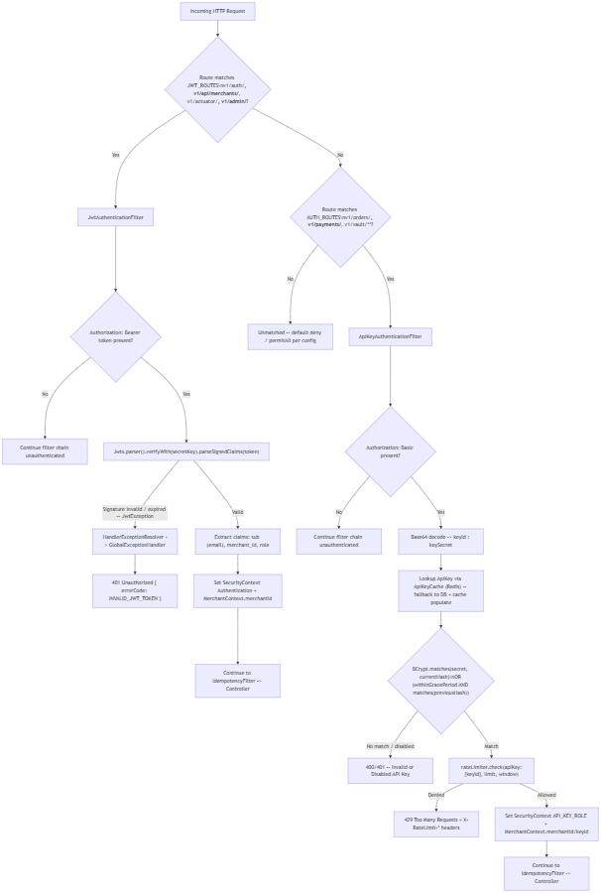

Key design points:
- Both filters route caught exceptions through HandlerExceptionResolver.resolveException(...) into GlobalExceptionHandler, ensuring a single consistent ErrorResponse shape for every failure path (security-layer or MVC-layer).
- JWT and API-Key are mutually exclusive route groups (@Order(1) / @Order(2) security filter chains via securityMatcher), so a request path is only ever subject to one authentication scheme.
- API key secrets and merchant login passwords both use BCryptPasswordEncoder — no reversible hashing of credentials anywhere in the system.
- Card PANs are never stored in payments/orders — only an opaque Vault token; the raw PAN lives solely in vault_cards.encrypted_pan, itself encrypted under a per-card DEK which is in turn wrapped by the master key (envelope encryption), giving two layers of key rotation without re-encrypting stored card data.

End of document.

